Week1

数据集收集。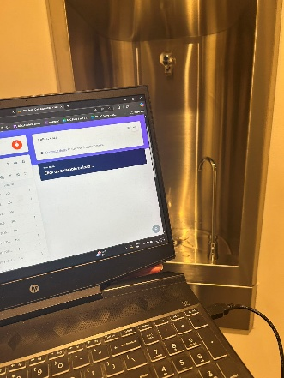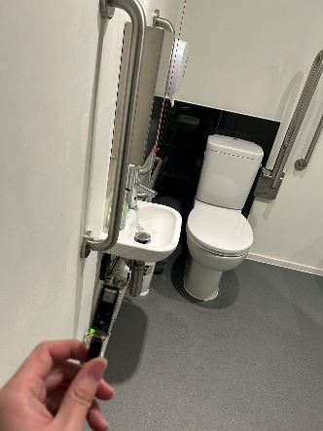

Week2

使用test 3已有数据集。

tes6.49已处理是我个人收集的数据集。

# 关于test 3的尝试：

根据tutorial的步骤制作的模型并不准确，错误识别为**faucet概率很高。我已经尝试了默认设置的classification，接下来将全部使用transfer learning。**

**但是教程中的epoch为30，我认为不对，我将尝试找到最佳的epoch.**

1/100

42/42 - 12s - loss: 0.5189 - accuracy: 0.9114 - val_loss: 0.3715 - val_accuracy: 0.9397 - 12s/ - 295ms/step

2/100

42/42 - 8s - loss: 0.3097 - accuracy: 0.9389 - val_loss: 0.2520 - val_accuracy: 0.9464 - 8s/ - 187ms/step

3/100

42/42 - 8s - loss: 0.2318 - accuracy: 0.9419 - val_loss: 0.2006 - val_accuracy: 0.9487 - 8s/ - 179ms/step

4/100

42/42 - 8s - loss: 0.1942 - accuracy: 0.9412 - val_loss: 0.1736 - val_accuracy: 0.9501 - 8s/ - 181ms/step

5/100

loss: 0.1711 - accuracy: 0.9479 - val_loss: 0.1563 - val_accuracy: 0.9509 - 7s/ - 172ms/step

6/100

loss: 0.1556 - accuracy: 0.9516 - val_loss: 0.1434 - val_accuracy: 0.9531 - 7s/ - 171ms/step

7/100

loss: 0.1433 - accuracy: 0.9576 - val_loss: 0.1352 - val_accuracy: 0.9546 - 7s/ - 174ms/step

8/100

loss: 0.1327 - accuracy: 0.9583 - val_loss: 0.1276 - val_accuracy: 0.9568 - 7s/ - 175ms/step

9/100

loss: 0.1279 - accuracy: 0.9598 - val_loss: 0.1217 - val_accuracy: 0.9576 - 7s/ - 175ms/step

10/100

loss: 0.1207 - accuracy: 0.9590 - val_loss: 0.1171 - val_accuracy: 0.9568 - 7s/ - 173ms/step

11/100

loss: 0.1167 - accuracy: 0.9620 - val_loss: 0.1131 - val_accuracy: 0.9576 - 7s/ - 166ms/step

12/100

loss: 0.1113 - accuracy: 0.9643 - val_loss: 0.1098 - val_accuracy: 0.9591 - 7s/ - 173ms/step

13/100

loss: 0.1067 - accuracy: 0.9643 - val_loss: 0.1068 - val_accuracy: 0.9591 - 7s/ - 174ms/step

14/100

loss: 0.1045 - accuracy: 0.9650 - val_loss: 0.1042 - val_accuracy: 0.9576 - 7s/ - 173ms/step

15/100

42/42 - 8s - loss: 0.0987 - accuracy: 0.9672 - val_loss: 0.1017 - val_accuracy: 0.9583 - 8s/ - 181ms/step

16/100

loss: 0.0971 - accuracy: 0.9695 - val_loss: 0.0991 - val_accuracy: 0.9583 - 7s/ - 175ms/step

17/100

42/42 - 8s - loss: 0.0924 - accuracy: 0.9732 - val_loss: 0.0979 - val_accuracy: 0.9576 - 8s/ - 179ms/step

18/100

loss: 0.0909 - accuracy: 0.9710 - val_loss: 0.0961 - val_accuracy: 0.9576 - 7s/ - 175ms/step

19/100

42/42 - 8s - loss: 0.0877 - accuracy: 0.9710 - val_loss: 0.0940 - val_accuracy: 0.9583 - 8s/ - 179ms/step

20/100

loss: 0.0854 - accuracy: 0.9724 - val_loss: 0.0925 - val_accuracy: 0.9606 - 7s/ - 178ms/step

21/100

loss: 0.0841 - accuracy: 0.9739 - val_loss: 0.0913 - val_accuracy: 0.9606 - 7s/ - 175ms/step

22/100

42/42 - 9s - loss: 0.0814 - accuracy: 0.9732 - val_loss: 0.0903 - val_accuracy: 0.9621 - 9s/ - 209ms/step

23/100

loss: 0.0787 - accuracy: 0.9762 - val_loss: 0.0894 - val_accuracy: 0.9643 - 7s/ - 178ms/step

24/100

23/100

loss: 0.0787 - accuracy: 0.9762 - val_loss: 0.0894 - val_accuracy: 0.9643 - 7s/ - 178ms/step

loss: 0.0776 - accuracy: 0.9724 - val_loss: 0.0877 - val_accuracy: 0.9621 - 7s/ - 176ms/step

25/100

loss: 0.0756 - accuracy: 0.9792 - val_loss: 0.0867 - val_accuracy: 0.9635 - 7s/ - 172ms/step

26/100

loss: 0.0740 - accuracy: 0.9747 - val_loss: 0.0858 - val_accuracy: 0.9650 - 7s/ - 169ms/step

27/100

loss: 0.0745 - accuracy: 0.9762 - val_loss: 0.0852 - val_accuracy: 0.9680 - 7s/ - 166ms/step

28/100

loss: 0.0715 - accuracy: 0.9784 - val_loss: 0.0841 - val_accuracy: 0.9673 - 7s/ - 167ms/step

29/100

loss: 0.0690 - accuracy: 0.9777 - val_loss: 0.0834 - val_accuracy: 0.9688 - 7s/ - 166ms/step

30/100

loss: 0.0687 - accuracy: 0.9762 - val_loss: 0.0823 - val_accuracy: 0.9665 - 7s/ - 164ms/step

31/100

loss: 0.0681 - accuracy: 0.9769 - val_loss: 0.0817 - val_accuracy: 0.9688 - 7s/ - 164ms/step

32/100

loss: 0.0672 - accuracy: 0.9806 - val_loss: 0.0814 - val_accuracy: 0.9695 - 7s/ - 166ms/step

33/100

loss: 0.0655 - accuracy: 0.9792 - val_loss: 0.0809 - val_accuracy: 0.9695 - 7s/ - 170ms/step

34/100

loss: 0.0651 - accuracy: 0.9799 - val_loss: 0.0799 - val_accuracy: 0.9688 - 7s/ - 171ms/step

35/100

loss: 0.0631 - accuracy: 0.9777 - val_loss: 0.0796 - val_accuracy: 0.9695 - 7s/ - 174ms/step

36/100

loss: 0.0627 - accuracy: 0.9814 - val_loss: 0.0791 - val_accuracy: 0.9695 - 7s/ - 172ms/step

37/100

42/42 - 9s - loss: 0.0623 - accuracy: 0.9821 - val_loss: 0.0791 - val_accuracy: 0.9725 - 9s/ - 203ms/step

38/100

loss: 0.0604 - accuracy: 0.9851 - val_loss: 0.0780 - val_accuracy: 0.9702 - 7s/ - 164ms/step

39/100

loss: 0.0576 - accuracy: 0.9806 - val_loss: 0.0778 - val_accuracy: 0.9725 - 7s/ - 169ms/step

40/100

loss: 0.0561 - accuracy: 0.9851 - val_loss: 0.0774 - val_accuracy: 0.9732 - 7s/ - 172ms/step

41/100

loss: 0.0575 - accuracy: 0.9829 - val_loss: 0.0765 - val_accuracy: 0.9710 - 7s/ - 177ms/step

42/100

loss: 0.0557 - accuracy: 0.9859 - val_loss: 0.0763 - val_accuracy: 0.9717 - 7s/ - 172ms/step

43/100

loss: 0.0524 - accuracy: 0.9859 - val_loss: 0.0758 - val_accuracy: 0.9725 - 7s/ - 172ms/step

44/100

loss: 0.0530 - accuracy: 0.9866 - val_loss: 0.0753 - val_accuracy: 0.9725 - 7s/ - 176ms/step

45/100

loss: 0.0528 - accuracy: 0.9873 - val_loss: 0.0754 - val_accuracy: 0.9740 - 7s/ - 169ms/step

46/100

loss: 0.0533 - accuracy: 0.9844 - val_loss: 0.0747 - val_accuracy: 0.9740 - 7s/ - 176ms/step

47/100

loss: 0.0508 - accuracy: 0.9881 - val_loss: 0.0745 - val_accuracy: 0.9740 - 7s/ - 173ms/step

48/100

loss: 0.0517 - accuracy: 0.9859 - val_loss: 0.0741 - val_accuracy: 0.9740 - 7s/ - 173ms/step

49/100

loss: 0.0511 - accuracy: 0.9851 - val_loss: 0.0742 - val_accuracy: 0.9732 - 7s/ - 168ms/step

50/100

loss: 0.0500 - accuracy: 0.9859 - val_loss: 0.0738 - val_accuracy: 0.9732 - 7s/ - 176ms/step

51/100

loss: 0.0477 - accuracy: 0.9881 - val_loss: 0.0732 - val_accuracy: 0.9732 - 7s/ - 178ms/step

52/100

loss: 0.0491 - accuracy: 0.9866 - val_loss: 0.0728 - val_accuracy: 0.9732 - 7s/ - 175ms/step

53/100

loss: 0.0479 - accuracy: 0.9866 - val_loss: 0.0727 - val_accuracy: 0.9740 - 7s/ - 173ms/step

54/100

loss: 0.0475 - accuracy: 0.9896 - val_loss: 0.0724 - val_accuracy: 0.9740 - 7s/ - 174ms/step

55/100

loss: 0.0448 - accuracy: 0.9918 - val_loss: 0.0722 - val_accuracy: 0.9740 - 7s/ - 170ms/step

56/100

loss: 0.0461 - accuracy: 0.9881 - val_loss: 0.0721 - val_accuracy: 0.9740 - 7s/ - 173ms/step

57/100

loss: 0.0454 - accuracy: 0.9896 - val_loss: 0.0715 - val_accuracy: 0.9725 - 7s/ - 168ms/step

58/100

loss: 0.0452 - accuracy: 0.9888 - val_loss: 0.0717 - val_accuracy: 0.9740 - 7s/ - 163ms/step

59/100

loss: 0.0437 - accuracy: 0.9881 - val_loss: 0.0716 - val_accuracy: 0.9740 - 7s/ - 164ms/step

60/100

loss: 0.0441 - accuracy: 0.9896 - val_loss: 0.0718 - val_accuracy: 0.9725 - 7s/ - 162ms/step

61/100

loss: 0.0430 - accuracy: 0.9903 - val_loss: 0.0713 - val_accuracy: 0.9732 - 7s/ - 172ms/step

62/100

loss: 0.0429 - accuracy: 0.9911 - val_loss: 0.0710 - val_accuracy: 0.9732 - 7s/ - 172ms/step

63/100

loss: 0.0433 - accuracy: 0.9896 - val_loss: 0.0707 - val_accuracy: 0.9740 - 7s/ - 169ms/step

64/100

loss: 0.0413 - accuracy: 0.9896 - val_loss: 0.0708 - val_accuracy: 0.9732 - 7s/ - 164ms/step

65/100

loss: 0.0424 - accuracy: 0.9896 - val_loss: 0.0708 - val_accuracy: 0.9732 - 7s/ - 164ms/step

66/100

loss: 0.0407 - accuracy: 0.9918 - val_loss: 0.0705 - val_accuracy: 0.9725 - 7s/ - 168ms/step

67/100

loss: 0.0407 - accuracy: 0.9918 - val_loss: 0.0705 - val_accuracy: 0.9725 - 7s/ - 168ms/step

67/100

loss: 0.0409 - accuracy: 0.9911 - val_loss: 0.0703 - val_accuracy: 0.9725 - 7s/ - 173ms/step

68/100

loss: 0.0402 - accuracy: 0.9918 - val_loss: 0.0704 - val_accuracy: 0.9732 - 7s/ - 170ms/step

69/100

loss: 0.0410 - accuracy: 0.9896 - val_loss: 0.0703 - val_accuracy: 0.9717 - 7s/ - 167ms/step

70/100

loss: 0.0382 - accuracy: 0.9918 - val_loss: 0.0706 - val_accuracy: 0.9740 - 7s/ - 165ms/step

71/100

loss: 0.0375 - accuracy: 0.9918 - val_loss: 0.0703 - val_accuracy: 0.9732 - 7s/ - 173ms/step

72/100

loss: 0.0369 - accuracy: 0.9933 - val_loss: 0.0701 - val_accuracy: 0.9740 - 7s/ - 177ms/step

73/100

42/42 - 8s - loss: 0.0383 - accuracy: 0.9911 - val_loss: 0.0695 - val_accuracy: 0.9732 - 8s/ - 182ms/step

74/100

loss: 0.0390 - accuracy: 0.9918 - val_loss: 0.0694 - val_accuracy: 0.9740 - 7s/ - 171ms/step

75/100

loss: 0.0391 - accuracy: 0.9911 - val_loss: 0.0690 - val_accuracy: 0.9732 - 7s/ - 170ms/step

76/100

loss: 0.0363 - accuracy: 0.9903 - val_loss: 0.0690 - val_accuracy: 0.9732 - 7s/ - 175ms/step

77/100

loss: 0.0369 - accuracy: 0.9918 - val_loss: 0.0692 - val_accuracy: 0.9747 - 7s/ - 170ms/step

78/100

loss: 0.0355 - accuracy: 0.9896 - val_loss: 0.0691 - val_accuracy: 0.9747 - 7s/ - 171ms/step

79/100

loss: 0.0345 - accuracy: 0.9948 - val_loss: 0.0687 - val_accuracy: 0.9732 - 7s/ - 174ms/step

80/100

loss: 0.0348 - accuracy: 0.9926 - val_loss: 0.0686 - val_accuracy: 0.9725 - 7s/ - 173ms/step

81/100

loss: 0.0383 - accuracy: 0.9888 - val_loss: 0.0688 - val_accuracy: 0.9754 - 7s/ - 169ms/step

82/100

loss: 0.0331 - accuracy: 0.9933 - val_loss: 0.0687 - val_accuracy: 0.9725 - 7s/ - 171ms/step

83/100

loss: 0.0336 - accuracy: 0.9940 - val_loss: 0.0686 - val_accuracy: 0.9740 - 7s/ - 171ms/step

84/100

loss: 0.0331 - accuracy: 0.9948 - val_loss: 0.0684 - val_accuracy: 0.9732 - 7s/ - 176ms/step

85/100

loss: 0.0335 - accuracy: 0.9940 - val_loss: 0.0683 - val_accuracy: 0.9725 - 7s/ - 174ms/step

86/100

loss: 0.0312 - accuracy: 0.9940 - val_loss: 0.0684 - val_accuracy: 0.9725 - 7s/ - 169ms/step

87/100

loss: 0.0321 - accuracy: 0.9926 - val_loss: 0.0685 - val_accuracy: 0.9725 - 7s/ - 171ms/step

88/100

42/42 - 9s - loss: 0.0347 - accuracy: 0.9933 - val_loss: 0.0685 - val_accuracy: 0.9740 - 9s/ - 206ms/step

89/100

loss: 0.0313 - accuracy: 0.9940 - val_loss: 0.0684 - val_accuracy: 0.9747 - 7s/ - 166ms/step

90/100

loss: 0.0323 - accuracy: 0.9933 - val_loss: 0.0680 - val_accuracy: 0.9732 - 7s/ - 170ms/step

91/100

loss: 0.0319 - accuracy: 0.9933 - val_loss: 0.0681 - val_accuracy: 0.9725 - 7s/ - 165ms/step

92/100

loss: 0.0307 - accuracy: 0.9933 - val_loss: 0.0684 - val_accuracy: 0.9717 - 7s/ - 171ms/step

93/100

loss: 0.0309 - accuracy: 0.9940 - val_loss: 0.0682 - val_accuracy: 0.9717 - 7s/ - 171ms/step

94/100

loss: 0.0291 - accuracy: 0.9918 - val_loss: 0.0682 - val_accuracy: 0.9717 - 7s/ - 170ms/step

95/100

loss: 0.0290 - accuracy: 0.9948 - val_loss: 0.0681 - val_accuracy: 0.9717 - 7s/ - 174ms/step

96/100

loss: 0.0292 - accuracy: 0.9940 - val_loss: 0.0687 - val_accuracy: 0.9740 - 7s/ - 171ms/step

97/100

loss: 0.0303 - accuracy: 0.9948 - val_loss: 0.0682 - val_accuracy: 0.9725 - 7s/ - 174ms/step

98/100

loss: 0.0309 - accuracy: 0.9926 - val_loss: 0.0681 - val_accuracy: 0.9710 - 7s/ - 171ms/step

99/100

loss: 0.0283 - accuracy: 0.9933 - val_loss: 0.0682 - val_accuracy: 0.9717 - 7s/ - 173ms/step

100/100

loss: 0.0262 - accuracy: 0.9970 - val_loss: 0.0684 - val_accuracy: 0.9717 - 7s/ - 171ms/step

Finished training

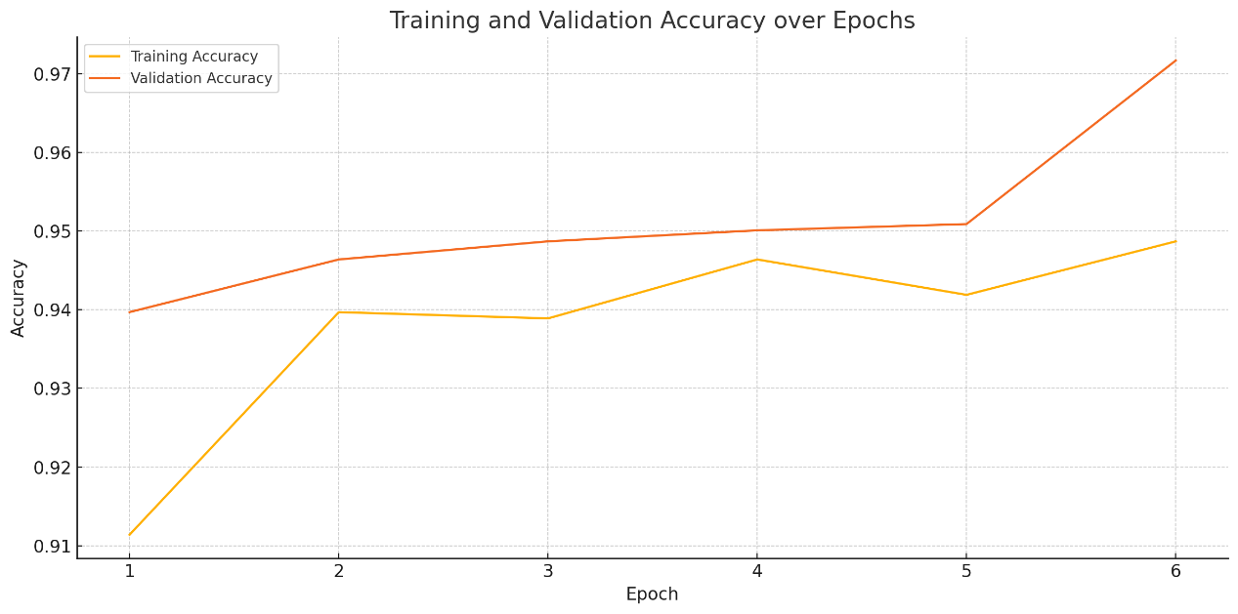

55 loss: 0.0448 - accuracy: 0.9918 - val_loss: 0.0722 - val_accuracy: 0.9740 - 7s/ - 170ms/step

72/100

loss: 0.0369 - accuracy: 0.9933 - val_loss: 0.0701 - val_accuracy: 0.9740 - 7s/ - 177ms/step

79/100

loss: 0.0345 - accuracy: 0.9948 - val_loss: 0.0687 - val_accuracy: 0.9732 - 7s/ - 174ms/step

89/100

loss: 0.0313 - accuracy: 0.9940 - val_loss: 0.0684 - val_accuracy: 0.9747 - 7s/ - 166ms/step

95/100

loss: 0.0290 - accuracy: 0.9948 - val_loss: 0.0681 - val_accuracy: 0.9717 - 7s/ - 174ms/step

97/100

loss: 0.0303 - accuracy: 0.9948 - val_loss: 0.0682 - val_accuracy: 0.9725 - 7s/ - 174ms/step

100/100

loss: 0.0262 - accuracy: 0.9970 - val_loss: 0.0684 - val_accuracy: 0.9717 - 7s/ - 171ms/step

尽管accuracy还在提高，但val accuracy从epoch89后再没提升过所有我认为最佳的epoch是89，考虑到性能和时长，我将之后的epoch都设置为80

即便如此，输出的模型还是完全不准确，上图中低于0.5的点都是误判。可惜的是我丢失了epoch 为30的那个模型，所以我无法进行对比。但我目前认为是数据集的问题。

改为80epoch也没优化。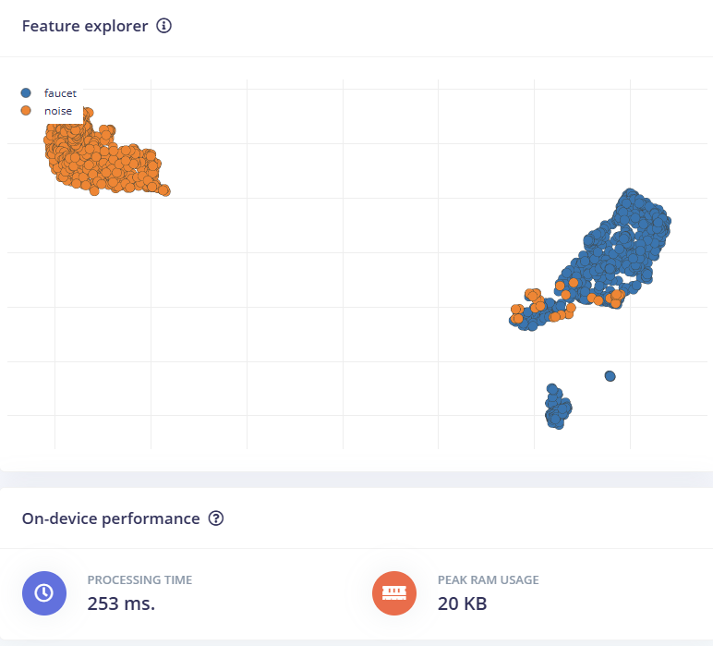  
毕竟无论是噪音还是水流声的特征点都过于集中，鲁棒性必然不好。

Modeling test的测试结果是同一数据集中的测试数据结果优秀，但是我自己录制的效果却很差。也可能是validationset太大了，我打了50，默认是20.我在下一版中改了回来，试试。

还是不行。几乎肯定是数据集的问题了。

# tes6.49已处理的尝试：

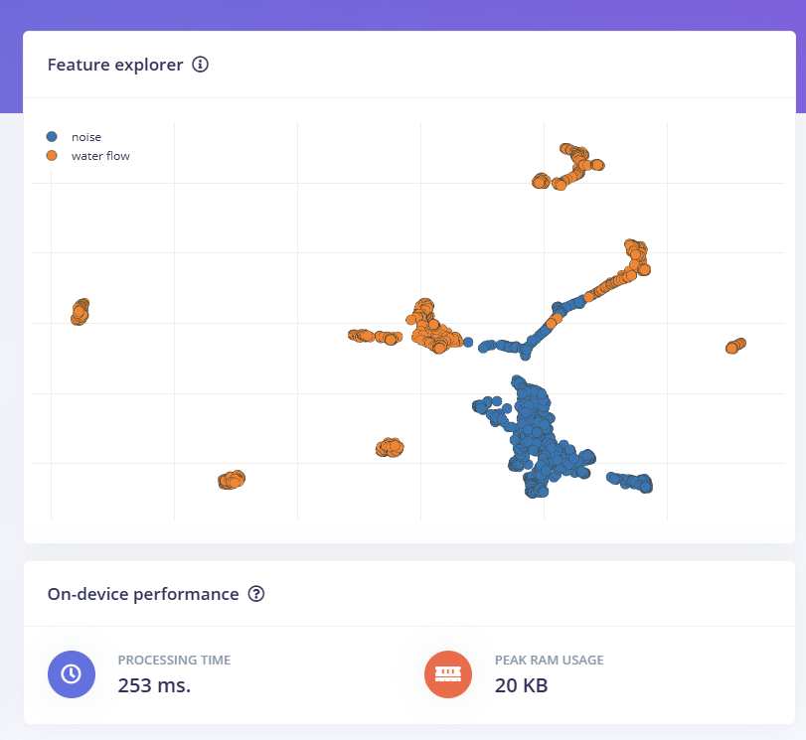  
两种类别的数据点重叠非常严重

没有明显的边界可以把 water flow 和 noise 区分开

有很多 orange 点（水流声）“插”在蓝色区域（背景噪声）里，反之亦然

|  |  |
| --- | --- |
| Frame length | 从 0.02 → 0.03 或 0.04（增加每帧时间） |

|  |  |
| --- | --- |
| Filter number | 从 40 → 60（更细的频率划分） |

|  |  |
| --- | --- |
| FFT length | 从 256 → 512（更高频率分辨率） |

|  |  |
| --- | --- |
| Low frequency | 试试从 300Hz 改为 100Hz（包含低频水声） |

|  |  |
| --- | --- |
| High frequency | 确保等于采样率的一半，比如 8000Hz |

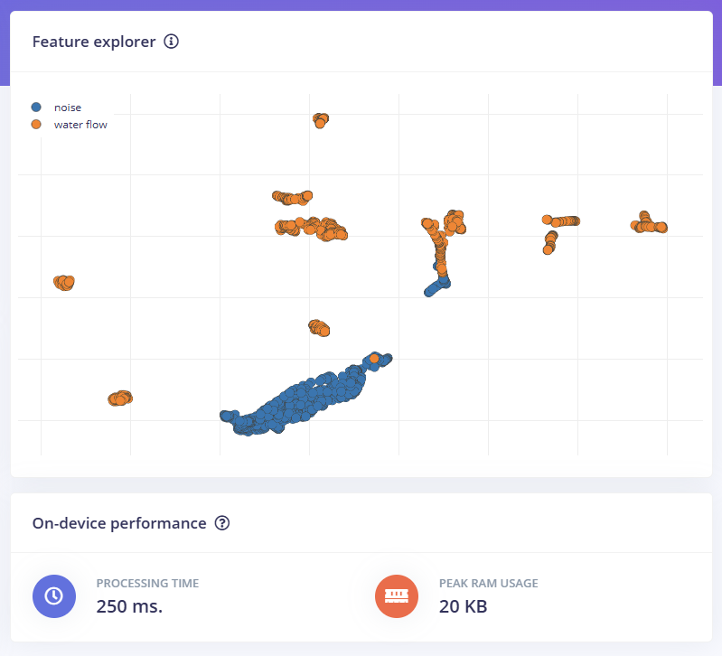

🟠 water flow 和 🔵 noise 现在已经开始分出一些明显的聚类块

蓝色的 noise 聚集得很紧密，说明特征相对统一（模型容易学）

橙色的 water flow 分散得稍微多一些，但也有清晰的多个子聚类

两类之间的“混色区域”明显减少

改进：

1尝试把水流声音按“流速”分为几类（例如 fast flow / slow flow），这样可能帮助模型分辨更细的特征，也可能降低类内变异。

2现在的 noise 表现非常好，但你可以再录一些更“复杂”的环境音（人说话、厕所冲水、电器运转），测试模型抗干扰能力。

3

| **参数** | **可以尝试** |
| --- | --- |

|  |  |
| --- | --- |
| Filter number | 40 → 60 |

|  |  |
| --- | --- |
| FFT length | 256 → 512 |

|  |  |
| --- | --- |
| Frame length | 0.02 → 0.03 |

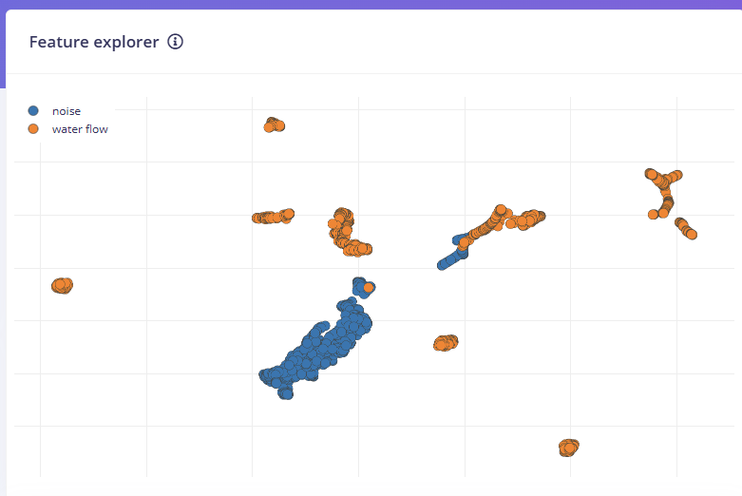

我也想在数据集中加入使用花洒的数据，但是使用花洒会有大量水雾，我担心它会破坏电路，在我完成防水设计前，我可能无法取得这部分数据。

我仍在继续优化数据集，目前家里的厨房还未出现在数据集中，可以作为testing set 的录制来使用。

数据集优化完成，第一次使用classification来训练，配置如下Input

→ Reshape (60 columns)

→ Conv1D (8 filters)

→ Dropout

→ Conv1D (16 filters)

→ Dropout

→ Conv1D (32 filters)

→ Dropout (可选)

→ Flatten

→ Dense Layer（例如 64 units，激活函数 relu）【推荐加】

→ Dropout（如 0.3）

→ Output (2 classes, softmax)

使用的MFE。



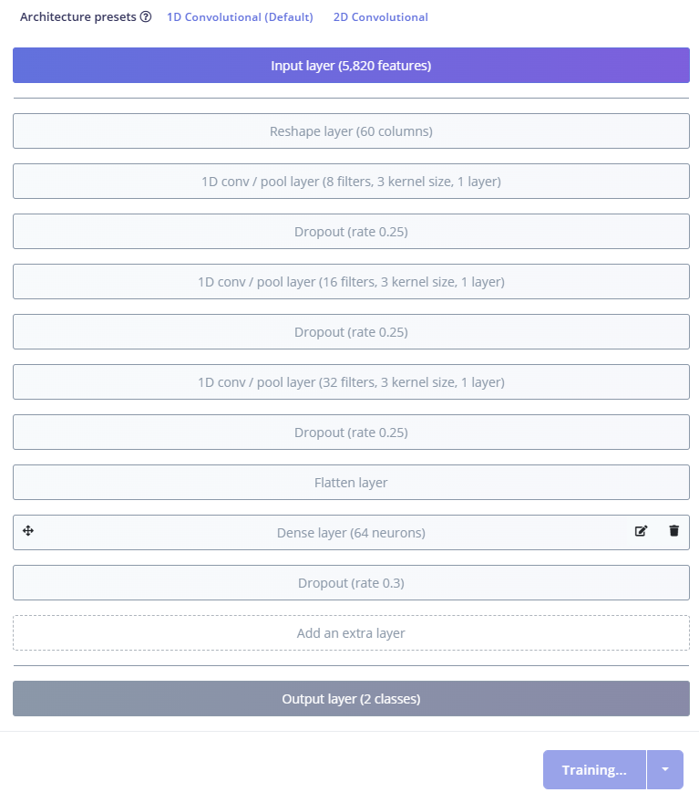

Epoch 1/100

91/91 - 9s - loss: 0.4094 - accuracy: 0.8266 - val_loss: 0.5996 - val_accuracy: 0.5879 - 9s/epoch - 98ms/step

Epoch 2/100

91/91 - 7s - loss: 0.2180 - accuracy: 0.9128 - val_loss: 0.4197 - val_accuracy: 0.6662 - 7s/epoch - 80ms/step

Epoch 3/100

91/91 - 7s - loss: 0.2052 - accuracy: 0.9238 - val_loss: 0.4653 - val_accuracy: 0.6387 - 7s/epoch - 81ms/step

Epoch 4/100

Epoch 94% done

91/91 - 7s - loss: 0.1963 - accuracy: 0.9231 - val_loss: 0.3784 - val_accuracy: 0.7459 - 7s/epoch - 81ms/step

Epoch 5/100

91/91 - 7s - loss: 0.1877 - accuracy: 0.9210 - val_loss: 0.3200 - val_accuracy: 0.7720 - 7s/epoch - 81ms/step

Epoch 6/100

91/91 - 7s - loss: 0.2076 - accuracy: 0.9207 - val_loss: 0.3635 - val_accuracy: 0.8846 - 7s/epoch - 82ms/step

Epoch 7/100

91/91 - 7s - loss: 0.2076 - accuracy: 0.9207 - val_loss: 0.3635 - val_accuracy: 0.8846 - 7s/epoch - 82ms/step

Epoch 7/100

91/91 - 7s - loss: 0.1929 - accuracy: 0.9306 - val_loss: 0.3333 - val_accuracy: 0.9025 - 7s/epoch - 79ms/step

Epoch 8/100

91/91 - 7s - loss: 0.1723 - accuracy: 0.9282 - val_loss: 0.3088 - val_accuracy: 0.9560 - 7s/epoch - 81ms/step

Epoch 9/100

91/91 - 7s - loss: 0.1853 - accuracy: 0.9317 - val_loss: 0.3460 - val_accuracy: 0.9409 - 7s/epoch - 82ms/step

Epoch 10/100

91/91 - 7s - loss: 0.1861 - accuracy: 0.9303 - val_loss: 0.3788 - val_accuracy: 0.8420 - 7s/epoch - 82ms/step

Epoch 11/100

91/91 - 7s - loss: 0.1677 - accuracy: 0.9279 - val_loss: 0.3027 - val_accuracy: 0.9093 - 7s/epoch - 80ms/step

Epoch 12/100

91/91 - 7s - loss: 0.1766 - accuracy: 0.9361 - val_loss: 0.2429 - val_accuracy: 0.9670 - 7s/epoch - 80ms/step

Epoch 13/100

91/91 - 7s - loss: 0.1708 - accuracy: 0.9368 - val_loss: 0.4256 - val_accuracy: 0.9025 - 7s/epoch - 81ms/step

Epoch 14/100

Epoch 95% done

91/91 - 7s - loss: 0.1671 - accuracy: 0.9361 - val_loss: 0.2465 - val_accuracy: 0.9588 - 7s/epoch - 80ms/step

Epoch 15/100

91/91 - 7s - loss: 0.2086 - accuracy: 0.9231 - val_loss: 0.2181 - val_accuracy: 0.9588 - 7s/epoch - 81ms/step

Epoch 16/100

91/91 - 7s - loss: 0.1974 - accuracy: 0.9227 - val_loss: 0.3080 - val_accuracy: 0.9602 - 7s/epoch - 80ms/step

Epoch 17/100

91/91 - 7s - loss: 0.1700 - accuracy: 0.9354 - val_loss: 0.2714 - val_accuracy: 0.8887 - 7s/epoch - 79ms/step

Epoch 18/100

91/91 - 7s - loss: 0.1826 - accuracy: 0.9200 - val_loss: 0.5880 - val_accuracy: 0.7596 - 7s/epoch - 81ms/step

Epoch 19/100

91/91 - 7s - loss: 0.1792 - accuracy: 0.9293 - val_loss: 0.3600 - val_accuracy: 0.8571 - 7s/epoch - 80ms/step

Epoch 20/100

91/91 - 7s - loss: 0.1870 - accuracy: 0.9320 - val_loss: 0.4814 - val_accuracy: 0.7005 - 7s/epoch - 80ms/step

Epoch 21/100

91/91 - 7s - loss: 0.1975 - accuracy: 0.9286 - val_loss: 0.2947 - val_accuracy: 0.8104 - 7s/epoch - 81ms/step

Epoch 22/100

91/91 - 7s - loss: 0.1878 - accuracy: 0.9265 - val_loss: 0.2336 - val_accuracy: 0.9148 - 7s/epoch - 81ms/step

Epoch 23/100

91/91 - 8s - loss: 0.1858 - accuracy: 0.9299 - val_loss: 0.2173 - val_accuracy: 0.9519 - 8s/epoch - 82ms/step

Epoch 24/100

91/91 - 8s - loss: 0.1858 - accuracy: 0.9299 - val_loss: 0.2173 - val_accuracy: 0.9519 - 8s/epoch - 82ms/step

Epoch 24/100

91/91 - 8s - loss: 0.1798 - accuracy: 0.9313 - val_loss: 0.2790 - val_accuracy: 0.9258 - 8s/epoch - 84ms/step

Epoch 25/100

91/91 - 8s - loss: 0.1614 - accuracy: 0.9341 - val_loss: 0.4944 - val_accuracy: 0.7115 - 8s/epoch - 83ms/step

Epoch 26/100

91/91 - 8s - loss: 0.1695 - accuracy: 0.9382 - val_loss: 0.4714 - val_accuracy: 0.7019 - 8s/epoch - 82ms/step

Epoch 27/100

91/91 - 7s - loss: 0.1675 - accuracy: 0.9365 - val_loss: 0.2832 - val_accuracy: 0.9409 - 7s/epoch - 80ms/step

Epoch 28/100

Epoch 89% done

91/91 - 8s - loss: 0.1664 - accuracy: 0.9299 - val_loss: 0.3960 - val_accuracy: 0.8654 - 8s/epoch - 83ms/step

Epoch 29/100

91/91 - 7s - loss: 0.1982 - accuracy: 0.9241 - val_loss: 0.3909 - val_accuracy: 0.7459 - 7s/epoch - 81ms/step

Epoch 30/100

91/91 - 7s - loss: 0.1758 - accuracy: 0.9275 - val_loss: 0.5271 - val_accuracy: 0.8448 - 7s/epoch - 82ms/step

Epoch 31/100

91/91 - 7s - loss: 0.1653 - accuracy: 0.9306 - val_loss: 0.5326 - val_accuracy: 0.6868 - 7s/epoch - 79ms/step

Epoch 32/100

91/91 - 7s - loss: 0.1794 - accuracy: 0.9293 - val_loss: 0.4058 - val_accuracy: 0.6621 - 7s/epoch - 79ms/step

Epoch 33/100

91/91 - 7s - loss: 0.1794 - accuracy: 0.9293 - val_loss: 0.4058 - val_accuracy: 0.6621 - 7s/epoch - 79ms/step

Epoch 33/100

91/91 - 7s - loss: 0.1868 - accuracy: 0.9286 - val_loss: 0.4602 - val_accuracy: 0.6030 - 7s/epoch - 80ms/step

Epoch 34/100

91/91 - 7s - loss: 0.1747 - accuracy: 0.9293 - val_loss: 0.4783 - val_accuracy: 0.6030 - 7s/epoch - 80ms/step

Epoch 35/100

91/91 - 7s - loss: 0.1783 - accuracy: 0.9251 - val_loss: 0.4855 - val_accuracy: 0.6003 - 7s/epoch - 80ms/step

Epoch 36/100

91/91 - 7s - loss: 0.1786 - accuracy: 0.9375 - val_loss: 0.3296 - val_accuracy: 0.9066 - 7s/epoch - 79ms/step

Epoch 37/100

91/91 - 7s - loss: 0.1698 - accuracy: 0.9399 - val_loss: 0.5353 - val_accuracy: 0.6195 - 7s/epoch - 81ms/step

Epoch 38/100

91/91 - 7s - loss: 0.1746 - accuracy: 0.9365 - val_loss: 0.4238 - val_accuracy: 0.6511 - 7s/epoch - 80ms/step

Epoch 39/100

91/91 - 7s - loss: 0.1908 - accuracy: 0.9306 - val_loss: 0.3981 - val_accuracy: 0.6401 - 7s/epoch - 80ms/step

Epoch 40/100

91/91 - 7s - loss: 0.1640 - accuracy: 0.9354 - val_loss: 0.3700 - val_accuracy: 0.6621 - 7s/epoch - 81ms/step

Epoch 41/100

91/91 - 8s - loss: 0.1714 - accuracy: 0.9354 - val_loss: 0.3552 - val_accuracy: 0.8901 - 8s/epoch - 82ms/step

Epoch 42/100

91/91 - 7s - loss: 0.1722 - accuracy: 0.9375 - val_loss: 0.4809 - val_accuracy: 0.8681 - 7s/epoch - 81ms/step

Epoch 43/100

91/91 - 7s - loss: 0.1724 - accuracy: 0.9251 - val_loss: 0.3866 - val_accuracy: 0.6937 - 7s/epoch - 80ms/step

Epoch 44/100

91/91 - 8s - loss: 0.1743 - accuracy: 0.9330 - val_loss: 0.3592 - val_accuracy: 0.7088 - 8s/epoch - 83ms/step

Epoch 45/100

91/91 - 7s - loss: 0.1722 - accuracy: 0.9320 - val_loss: 0.3447 - val_accuracy: 0.6758 - 7s/epoch - 80ms/step

Epoch 46/100

91/91 - 7s - loss: 0.1617 - accuracy: 0.9327 - val_loss: 0.4311 - val_accuracy: 0.6538 - 7s/epoch - 82ms/step

Epoch 47/100

91/91 - 7s - loss: 0.1792 - accuracy: 0.9358 - val_loss: 0.5110 - val_accuracy: 0.6841 - 7s/epoch - 81ms/step

Epoch 48/100

91/91 - 7s - loss: 0.1636 - accuracy: 0.9382 - val_loss: 0.4670 - val_accuracy: 0.6593 - 7s/epoch - 81ms/step

Epoch 49/100

91/91 - 7s - loss: 0.1780 - accuracy: 0.9337 - val_loss: 0.3485 - val_accuracy: 0.7390 - 7s/epoch - 81ms/step

Epoch 50/100

91/91 - 8s - loss: 0.1761 - accuracy: 0.9348 - val_loss: 0.3453 - val_accuracy: 0.7390 - 8s/epoch - 83ms/step

Epoch 51/100

91/91 - 7s - loss: 0.1654 - accuracy: 0.9341 - val_loss: 0.3120 - val_accuracy: 0.8448 - 7s/epoch - 81ms/step

Epoch 52/100

91/91 - 7s - loss: 0.1688 - accuracy: 0.9354 - val_loss: 0.2225 - val_accuracy: 0.9684 - 7s/epoch - 81ms/step

Epoch 53/100

91/91 - 7s - loss: 0.1804 - accuracy: 0.9396 - val_loss: 0.3547 - val_accuracy: 0.9492 - 7s/epoch - 80ms/step

Epoch 54/100

91/91 - 7s - loss: 0.1699 - accuracy: 0.9323 - val_loss: 0.2129 - val_accuracy: 0.9602 - 7s/epoch - 81ms/step

Epoch 55/100

91/91 - 7s - loss: 0.1600 - accuracy: 0.9358 - val_loss: 0.2089 - val_accuracy: 0.9753 - 7s/epoch - 81ms/step

Epoch 56/100

91/91 - 7s - loss: 0.1835 - accuracy: 0.9406 - val_loss: 0.2760 - val_accuracy: 0.7885 - 7s/epoch - 80ms/step

Epoch 57/100

91/91 - 7s - loss: 0.1629 - accuracy: 0.9341 - val_loss: 0.2800 - val_accuracy: 0.7871 - 7s/epoch - 81ms/step

Epoch 58/100

91/91 - 7s - loss: 0.1678 - accuracy: 0.9348 - val_loss: 0.2843 - val_accuracy: 0.9203 - 7s/epoch - 81ms/step

Epoch 59/100

Epoch 58/100

91/91 - 7s - loss: 0.1678 - accuracy: 0.9348 - val_loss: 0.2843 - val_accuracy: 0.9203 - 7s/epoch - 81ms/step

91/91 - 7s - loss: 0.1655 - accuracy: 0.9348 - val_loss: 0.3008 - val_accuracy: 0.9396 - 7s/epoch - 80ms/step

Epoch 60/100

91/91 - 7s - loss: 0.1665 - accuracy: 0.9365 - val_loss: 0.2694 - val_accuracy: 0.8448 - 7s/epoch - 80ms/step

Epoch 61/100

91/91 - 7s - loss: 0.1909 - accuracy: 0.9303 - val_loss: 0.3343 - val_accuracy: 0.7898 - 7s/epoch - 79ms/step

Epoch 62/100

91/91 - 7s - loss: 0.1696 - accuracy: 0.9365 - val_loss: 0.2512 - val_accuracy: 0.8146 - 7s/epoch - 79ms/step

Epoch 63/100

91/91 - 7s - loss: 0.1854 - accuracy: 0.9303 - val_loss: 0.2658 - val_accuracy: 0.8297 - 7s/epoch - 80ms/step

Epoch 64/100

91/91 - 7s - loss: 0.1539 - accuracy: 0.9402 - val_loss: 0.2222 - val_accuracy: 0.8984 - 7s/epoch - 80ms/step

Epoch 65/100

91/91 - 7s - loss: 0.1827 - accuracy: 0.9293 - val_loss: 0.2625 - val_accuracy: 0.9464 - 7s/epoch - 79ms/step

Epoch 66/100

91/91 - 7s - loss: 0.1752 - accuracy: 0.9354 - val_loss: 0.2448 - val_accuracy: 0.9245 - 7s/epoch - 80ms/step

Epoch 67/100

Epoch 92% done

91/91 - 7s - loss: 0.1738 - accuracy: 0.9344 - val_loss: 0.3043 - val_accuracy: 0.9643 - 7s/epoch - 80ms/step

Epoch 68/100

Epoch 92% done

91/91 - 7s - loss: 0.1738 - accuracy: 0.9344 - val_loss: 0.3043 - val_accuracy: 0.9643 - 7s/epoch - 80ms/step

91/91 - 7s - loss: 0.2157 - accuracy: 0.9159 - val_loss: 0.1824 - val_accuracy: 0.9753 - 7s/epoch - 80ms/step

Epoch 69/100

Epoch 91% done

91/91 - 7s - loss: 0.1783 - accuracy: 0.9269 - val_loss: 0.2721 - val_accuracy: 0.8709 - 7s/epoch - 80ms/step

Epoch 70/100

Epoch 93% done

91/91 - 7s - loss: 0.1695 - accuracy: 0.9296 - val_loss: 0.2069 - val_accuracy: 0.9725 - 7s/epoch - 80ms/step

Epoch 71/100

91/91 - 7s - loss: 0.1809 - accuracy: 0.9293 - val_loss: 0.2716 - val_accuracy: 0.9533 - 7s/epoch - 79ms/step

Epoch 72/100

91/91 - 7s - loss: 0.1718 - accuracy: 0.9217 - val_loss: 0.2662 - val_accuracy: 0.9492 - 7s/epoch - 81ms/step

Epoch 73/100

91/91 - 7s - loss: 0.1774 - accuracy: 0.9323 - val_loss: 0.4017 - val_accuracy: 0.8297 - 7s/epoch - 78ms/step

Epoch 74/100

91/91 - 7s - loss: 0.1759 - accuracy: 0.9323 - val_loss: 0.2408 - val_accuracy: 0.9313 - 7s/epoch - 81ms/step

Epoch 75/100

91/91 - 7s - loss: 0.1696 - accuracy: 0.9337 - val_loss: 0.2716 - val_accuracy: 0.9354 - 7s/epoch - 82ms/step

Epoch 76/100

91/91 - 7s - loss: 0.1540 - accuracy: 0.9334 - val_loss: 0.2583 - val_accuracy: 0.9354 - 7s/epoch - 79ms/step

Epoch 77/100

91/91 - 7s - loss: 0.1619 - accuracy: 0.9354 - val_loss: 0.2348 - val_accuracy: 0.9217 - 7s/epoch - 80ms/step

Epoch 78/100

91/91 - 7s - loss: 0.1687 - accuracy: 0.9341 - val_loss: 0.2226 - val_accuracy: 0.9492 - 7s/epoch - 82ms/step

Epoch 79/100

91/91 - 7s - loss: 0.1652 - accuracy: 0.9330 - val_loss: 0.2123 - val_accuracy: 0.9299 - 7s/epoch - 79ms/step

Epoch 80/100

91/91 - 7s - loss: 0.1733 - accuracy: 0.9334 - val_loss: 0.2372 - val_accuracy: 0.9396 - 7s/epoch - 79ms/step

Epoch 81/100

91/91 - 7s - loss: 0.1844 - accuracy: 0.9303 - val_loss: 0.2794 - val_accuracy: 0.9245 - 7s/epoch - 78ms/step

Epoch 82/100

91/91 - 7s - loss: 0.1711 - accuracy: 0.9289 - val_loss: 0.2871 - val_accuracy: 0.9327 - 7s/epoch - 78ms/step

Epoch 83/100

91/91 - 7s - loss: 0.1561 - accuracy: 0.9378 - val_loss: 0.2440 - val_accuracy: 0.9505 - 7s/epoch - 78ms/step

Epoch 84/100

91/91 - 7s - loss: 0.1929 - accuracy: 0.9365 - val_loss: 0.2081 - val_accuracy: 0.9382 - 7s/epoch - 77ms/step

Epoch 85/100

91/91 - 7s - loss: 0.1550 - accuracy: 0.9368 - val_loss: 0.2321 - val_accuracy: 0.9574 - 7s/epoch - 79ms/step

Epoch 86/100

91/91 - 7s - loss: 0.1548 - accuracy: 0.9392 - val_loss: 0.1999 - val_accuracy: 0.9492 - 7s/epoch - 80ms/step

Epoch 87/100

91/91 - 7s - loss: 0.1549 - accuracy: 0.9382 - val_loss: 0.2007 - val_accuracy: 0.9560 - 7s/epoch - 80ms/step

Epoch 88/100

91/91 - 7s - loss: 0.1892 - accuracy: 0.9248 - val_loss: 0.2844 - val_accuracy: 0.9464 - 7s/epoch - 80ms/step

Epoch 89/100

91/91 - 7s - loss: 0.1660 - accuracy: 0.9358 - val_loss: 0.2346 - val_accuracy: 0.9437 - 7s/epoch - 81ms/step

Epoch 90/100

91/91 - 7s - loss: 0.1615 - accuracy: 0.9299 - val_loss: 0.2462 - val_accuracy: 0.9505 - 7s/epoch - 79ms/step

Epoch 91/100

91/91 - 7s - loss: 0.1645 - accuracy: 0.9365 - val_loss: 0.3747 - val_accuracy: 0.8997 - 7s/epoch - 81ms/step

Epoch 92/100

91/91 - 7s - loss: 0.1744 - accuracy: 0.9351 - val_loss: 0.4291 - val_accuracy: 0.9533 - 7s/epoch - 80ms/step

Epoch 93/100

91/91 - 7s - loss: 0.1525 - accuracy: 0.9416 - val_loss: 0.3768 - val_accuracy: 0.9574 - 7s/epoch - 80ms/step

Epoch 94/100

91/91 - 7s - loss: 0.1572 - accuracy: 0.9392 - val_loss: 0.2867 - val_accuracy: 0.9615 - 7s/epoch - 78ms/step

Epoch 95/100

91/91 - 7s - loss: 0.1571 - accuracy: 0.9444 - val_loss: 0.3011 - val_accuracy: 0.8956 - 7s/epoch - 78ms/step

Epoch 96/100

91/91 - 7s - loss: 0.1765 - accuracy: 0.9337 - val_loss: 0.2230 - val_accuracy: 0.9533 - 7s/epoch - 78ms/step

Epoch 97/100

91/91 - 7s - loss: 0.1728 - accuracy: 0.9337 - val_loss: 0.1771 - val_accuracy: 0.9464 - 7s/epoch - 78ms/step

Epoch 98/100

91/91 - 7s - loss: 0.1821 - accuracy: 0.9279 - val_loss: 0.2120 - val_accuracy: 0.9464 - 7s/epoch - 78ms/step

Epoch 99/100

91/91 - 7s - loss: 0.1600 - accuracy: 0.9330 - val_loss: 0.1858 - val_accuracy: 0.9451 - 7s/epoch - 78ms/step

Epoch 100/100

91/91 - 7s - loss: 0.1619 - accuracy: 0.9382 - val_loss: 0.2028 - val_accuracy: 0.9519 - 7s/epoch - 80ms/step

Finished training  
我需要先做一样的事情，用100epoch找出最佳epoch是多少。同时也可以将这个模型先保存，测试其正确率。

好吧这个模型完全没有保留的必要，算了吧。错误比较多的是捏瓶子的噪音和有很强底噪的安静房间。我认为是底噪的问题，所以我把low frequency改为300并把Noise floor (dB)改为-60。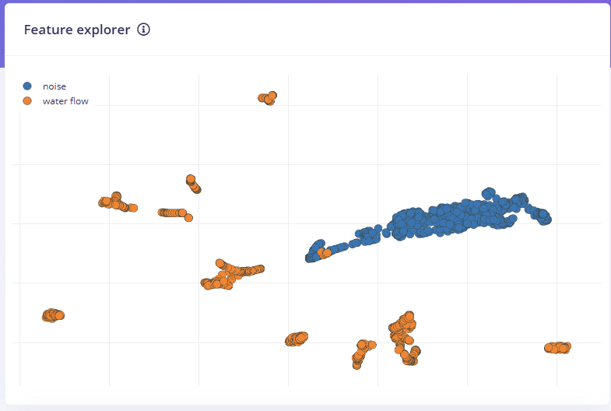  
感觉还行。将epoch改为50进行尝试

Epoch 1/100

91/91 - 9s - loss: 0.4094 - accuracy: 0.8266 - val_loss: 0.5996 - val_accuracy: 0.5879 - 9s/epoch - 98ms/step

Epoch 2/100

91/91 - 7s - loss: 0.2180 - accuracy: 0.9128 - val_loss: 0.4197 - val_accuracy: 0.6662 - 7s/epoch - 80ms/step

Epoch 3/100

91/91 - 7s - loss: 0.2052 - accuracy: 0.9238 - val_loss: 0.4653 - val_accuracy: 0.6387 - 7s/epoch - 81ms/step

Epoch 4/100

Epoch 94% done

91/91 - 7s - loss: 0.1963 - accuracy: 0.9231 - val_loss: 0.3784 - val_accuracy: 0.7459 - 7s/epoch - 81ms/step

Epoch 5/100

91/91 - 7s - loss: 0.1877 - accuracy: 0.9210 - val_loss: 0.3200 - val_accuracy: 0.7720 - 7s/epoch - 81ms/step

Epoch 6/100

91/91 - 7s - loss: 0.2076 - accuracy: 0.9207 - val_loss: 0.3635 - val_accuracy: 0.8846 - 7s/epoch - 82ms/step

Epoch 7/100

91/91 - 7s - loss: 0.2076 - accuracy: 0.9207 - val_loss: 0.3635 - val_accuracy: 0.8846 - 7s/epoch - 82ms/step

Epoch 7/100

91/91 - 7s - loss: 0.1929 - accuracy: 0.9306 - val_loss: 0.3333 - val_accuracy: 0.9025 - 7s/epoch - 79ms/step

Epoch 8/100

91/91 - 7s - loss: 0.1723 - accuracy: 0.9282 - val_loss: 0.3088 - val_accuracy: 0.9560 - 7s/epoch - 81ms/step

Epoch 9/100

91/91 - 7s - loss: 0.1853 - accuracy: 0.9317 - val_loss: 0.3460 - val_accuracy: 0.9409 - 7s/epoch - 82ms/step

Epoch 10/100

91/91 - 7s - loss: 0.1861 - accuracy: 0.9303 - val_loss: 0.3788 - val_accuracy: 0.8420 - 7s/epoch - 82ms/step

Epoch 11/100

91/91 - 7s - loss: 0.1677 - accuracy: 0.9279 - val_loss: 0.3027 - val_accuracy: 0.9093 - 7s/epoch - 80ms/step

Epoch 12/100

91/91 - 7s - loss: 0.1766 - accuracy: 0.9361 - val_loss: 0.2429 - val_accuracy: 0.9670 - 7s/epoch - 80ms/step

Epoch 13/100

91/91 - 7s - loss: 0.1708 - accuracy: 0.9368 - val_loss: 0.4256 - val_accuracy: 0.9025 - 7s/epoch - 81ms/step

Epoch 14/100

Epoch 95% done

91/91 - 7s - loss: 0.1671 - accuracy: 0.9361 - val_loss: 0.2465 - val_accuracy: 0.9588 - 7s/epoch - 80ms/step

Epoch 15/100

91/91 - 7s - loss: 0.2086 - accuracy: 0.9231 - val_loss: 0.2181 - val_accuracy: 0.9588 - 7s/epoch - 81ms/step

Epoch 16/100

91/91 - 7s - loss: 0.1974 - accuracy: 0.9227 - val_loss: 0.3080 - val_accuracy: 0.9602 - 7s/epoch - 80ms/step

Epoch 17/100

91/91 - 7s - loss: 0.1700 - accuracy: 0.9354 - val_loss: 0.2714 - val_accuracy: 0.8887 - 7s/epoch - 79ms/step

Epoch 18/100

91/91 - 7s - loss: 0.1826 - accuracy: 0.9200 - val_loss: 0.5880 - val_accuracy: 0.7596 - 7s/epoch - 81ms/step

Epoch 19/100

91/91 - 7s - loss: 0.1792 - accuracy: 0.9293 - val_loss: 0.3600 - val_accuracy: 0.8571 - 7s/epoch - 80ms/step

Epoch 20/100

91/91 - 7s - loss: 0.1870 - accuracy: 0.9320 - val_loss: 0.4814 - val_accuracy: 0.7005 - 7s/epoch - 80ms/step

Epoch 21/100

91/91 - 7s - loss: 0.1975 - accuracy: 0.9286 - val_loss: 0.2947 - val_accuracy: 0.8104 - 7s/epoch - 81ms/step

Epoch 22/100

91/91 - 7s - loss: 0.1878 - accuracy: 0.9265 - val_loss: 0.2336 - val_accuracy: 0.9148 - 7s/epoch - 81ms/step

Epoch 23/100

91/91 - 8s - loss: 0.1858 - accuracy: 0.9299 - val_loss: 0.2173 - val_accuracy: 0.9519 - 8s/epoch - 82ms/step

Epoch 24/100

91/91 - 8s - loss: 0.1858 - accuracy: 0.9299 - val_loss: 0.2173 - val_accuracy: 0.9519 - 8s/epoch - 82ms/step

Epoch 24/100

91/91 - 8s - loss: 0.1798 - accuracy: 0.9313 - val_loss: 0.2790 - val_accuracy: 0.9258 - 8s/epoch - 84ms/step

Epoch 25/100

91/91 - 8s - loss: 0.1614 - accuracy: 0.9341 - val_loss: 0.4944 - val_accuracy: 0.7115 - 8s/epoch - 83ms/step

Epoch 26/100

91/91 - 8s - loss: 0.1695 - accuracy: 0.9382 - val_loss: 0.4714 - val_accuracy: 0.7019 - 8s/epoch - 82ms/step

Epoch 27/100

91/91 - 7s - loss: 0.1675 - accuracy: 0.9365 - val_loss: 0.2832 - val_accuracy: 0.9409 - 7s/epoch - 80ms/step

Epoch 28/100

Epoch 89% done

91/91 - 8s - loss: 0.1664 - accuracy: 0.9299 - val_loss: 0.3960 - val_accuracy: 0.8654 - 8s/epoch - 83ms/step

Epoch 29/100

91/91 - 7s - loss: 0.1982 - accuracy: 0.9241 - val_loss: 0.3909 - val_accuracy: 0.7459 - 7s/epoch - 81ms/step

Epoch 30/100

91/91 - 7s - loss: 0.1758 - accuracy: 0.9275 - val_loss: 0.5271 - val_accuracy: 0.8448 - 7s/epoch - 82ms/step

Epoch 31/100

91/91 - 7s - loss: 0.1653 - accuracy: 0.9306 - val_loss: 0.5326 - val_accuracy: 0.6868 - 7s/epoch - 79ms/step

Epoch 32/100

91/91 - 7s - loss: 0.1794 - accuracy: 0.9293 - val_loss: 0.4058 - val_accuracy: 0.6621 - 7s/epoch - 79ms/step

Epoch 33/100

91/91 - 7s - loss: 0.1794 - accuracy: 0.9293 - val_loss: 0.4058 - val_accuracy: 0.6621 - 7s/epoch - 79ms/step

Epoch 33/100

91/91 - 7s - loss: 0.1868 - accuracy: 0.9286 - val_loss: 0.4602 - val_accuracy: 0.6030 - 7s/epoch - 80ms/step

Epoch 34/100

91/91 - 7s - loss: 0.1747 - accuracy: 0.9293 - val_loss: 0.4783 - val_accuracy: 0.6030 - 7s/epoch - 80ms/step

Epoch 35/100

91/91 - 7s - loss: 0.1783 - accuracy: 0.9251 - val_loss: 0.4855 - val_accuracy: 0.6003 - 7s/epoch - 80ms/step

Epoch 36/100

91/91 - 7s - loss: 0.1786 - accuracy: 0.9375 - val_loss: 0.3296 - val_accuracy: 0.9066 - 7s/epoch - 79ms/step

Epoch 37/100

91/91 - 7s - loss: 0.1698 - accuracy: 0.9399 - val_loss: 0.5353 - val_accuracy: 0.6195 - 7s/epoch - 81ms/step

Epoch 38/100

91/91 - 7s - loss: 0.1746 - accuracy: 0.9365 - val_loss: 0.4238 - val_accuracy: 0.6511 - 7s/epoch - 80ms/step

Epoch 39/100

91/91 - 7s - loss: 0.1908 - accuracy: 0.9306 - val_loss: 0.3981 - val_accuracy: 0.6401 - 7s/epoch - 80ms/step

Epoch 40/100

91/91 - 7s - loss: 0.1640 - accuracy: 0.9354 - val_loss: 0.3700 - val_accuracy: 0.6621 - 7s/epoch - 81ms/step

Epoch 41/100

91/91 - 8s - loss: 0.1714 - accuracy: 0.9354 - val_loss: 0.3552 - val_accuracy: 0.8901 - 8s/epoch - 82ms/step

Epoch 42/100

91/91 - 7s - loss: 0.1722 - accuracy: 0.9375 - val_loss: 0.4809 - val_accuracy: 0.8681 - 7s/epoch - 81ms/step

Epoch 43/100

91/91 - 7s - loss: 0.1724 - accuracy: 0.9251 - val_loss: 0.3866 - val_accuracy: 0.6937 - 7s/epoch - 80ms/step

Epoch 44/100

91/91 - 8s - loss: 0.1743 - accuracy: 0.9330 - val_loss: 0.3592 - val_accuracy: 0.7088 - 8s/epoch - 83ms/step

Epoch 45/100

91/91 - 7s - loss: 0.1722 - accuracy: 0.9320 - val_loss: 0.3447 - val_accuracy: 0.6758 - 7s/epoch - 80ms/step

Epoch 46/100

91/91 - 7s - loss: 0.1617 - accuracy: 0.9327 - val_loss: 0.4311 - val_accuracy: 0.6538 - 7s/epoch - 82ms/step

Epoch 47/100

91/91 - 7s - loss: 0.1792 - accuracy: 0.9358 - val_loss: 0.5110 - val_accuracy: 0.6841 - 7s/epoch - 81ms/step

Epoch 48/100

91/91 - 7s - loss: 0.1636 - accuracy: 0.9382 - val_loss: 0.4670 - val_accuracy: 0.6593 - 7s/epoch - 81ms/step

Epoch 49/100

91/91 - 7s - loss: 0.1780 - accuracy: 0.9337 - val_loss: 0.3485 - val_accuracy: 0.7390 - 7s/epoch - 81ms/step

Epoch 50/100

91/91 - 8s - loss: 0.1761 - accuracy: 0.9348 - val_loss: 0.3453 - val_accuracy: 0.7390 - 8s/epoch - 83ms/step

Epoch 51/100

91/91 - 7s - loss: 0.1654 - accuracy: 0.9341 - val_loss: 0.3120 - val_accuracy: 0.8448 - 7s/epoch - 81ms/step

Epoch 52/100

91/91 - 7s - loss: 0.1688 - accuracy: 0.9354 - val_loss: 0.2225 - val_accuracy: 0.9684 - 7s/epoch - 81ms/step

Epoch 53/100

91/91 - 7s - loss: 0.1804 - accuracy: 0.9396 - val_loss: 0.3547 - val_accuracy: 0.9492 - 7s/epoch - 80ms/step

Epoch 54/100

91/91 - 7s - loss: 0.1699 - accuracy: 0.9323 - val_loss: 0.2129 - val_accuracy: 0.9602 - 7s/epoch - 81ms/step

Epoch 55/100

91/91 - 7s - loss: 0.1600 - accuracy: 0.9358 - val_loss: 0.2089 - val_accuracy: 0.9753 - 7s/epoch - 81ms/step

Epoch 56/100

91/91 - 7s - loss: 0.1835 - accuracy: 0.9406 - val_loss: 0.2760 - val_accuracy: 0.7885 - 7s/epoch - 80ms/step

Epoch 57/100

91/91 - 7s - loss: 0.1629 - accuracy: 0.9341 - val_loss: 0.2800 - val_accuracy: 0.7871 - 7s/epoch - 81ms/step

Epoch 58/100

91/91 - 7s - loss: 0.1678 - accuracy: 0.9348 - val_loss: 0.2843 - val_accuracy: 0.9203 - 7s/epoch - 81ms/step

Epoch 59/100

Epoch 58/100

91/91 - 7s - loss: 0.1678 - accuracy: 0.9348 - val_loss: 0.2843 - val_accuracy: 0.9203 - 7s/epoch - 81ms/step

91/91 - 7s - loss: 0.1655 - accuracy: 0.9348 - val_loss: 0.3008 - val_accuracy: 0.9396 - 7s/epoch - 80ms/step

Epoch 60/100

91/91 - 7s - loss: 0.1665 - accuracy: 0.9365 - val_loss: 0.2694 - val_accuracy: 0.8448 - 7s/epoch - 80ms/step

Epoch 61/100

91/91 - 7s - loss: 0.1909 - accuracy: 0.9303 - val_loss: 0.3343 - val_accuracy: 0.7898 - 7s/epoch - 79ms/step

Epoch 62/100

91/91 - 7s - loss: 0.1696 - accuracy: 0.9365 - val_loss: 0.2512 - val_accuracy: 0.8146 - 7s/epoch - 79ms/step

Epoch 63/100

91/91 - 7s - loss: 0.1854 - accuracy: 0.9303 - val_loss: 0.2658 - val_accuracy: 0.8297 - 7s/epoch - 80ms/step

Epoch 64/100

91/91 - 7s - loss: 0.1539 - accuracy: 0.9402 - val_loss: 0.2222 - val_accuracy: 0.8984 - 7s/epoch - 80ms/step

Epoch 65/100

91/91 - 7s - loss: 0.1827 - accuracy: 0.9293 - val_loss: 0.2625 - val_accuracy: 0.9464 - 7s/epoch - 79ms/step

Epoch 66/100

91/91 - 7s - loss: 0.1752 - accuracy: 0.9354 - val_loss: 0.2448 - val_accuracy: 0.9245 - 7s/epoch - 80ms/step

Epoch 67/100

Epoch 92% done

91/91 - 7s - loss: 0.1738 - accuracy: 0.9344 - val_loss: 0.3043 - val_accuracy: 0.9643 - 7s/epoch - 80ms/step

Epoch 68/100

Epoch 92% done

91/91 - 7s - loss: 0.1738 - accuracy: 0.9344 - val_loss: 0.3043 - val_accuracy: 0.9643 - 7s/epoch - 80ms/step

91/91 - 7s - loss: 0.2157 - accuracy: 0.9159 - val_loss: 0.1824 - val_accuracy: 0.9753 - 7s/epoch - 80ms/step

Epoch 69/100

Epoch 91% done

91/91 - 7s - loss: 0.1783 - accuracy: 0.9269 - val_loss: 0.2721 - val_accuracy: 0.8709 - 7s/epoch - 80ms/step

Epoch 70/100

Epoch 93% done

91/91 - 7s - loss: 0.1695 - accuracy: 0.9296 - val_loss: 0.2069 - val_accuracy: 0.9725 - 7s/epoch - 80ms/step

Epoch 71/100

91/91 - 7s - loss: 0.1809 - accuracy: 0.9293 - val_loss: 0.2716 - val_accuracy: 0.9533 - 7s/epoch - 79ms/step

Epoch 72/100

91/91 - 7s - loss: 0.1718 - accuracy: 0.9217 - val_loss: 0.2662 - val_accuracy: 0.9492 - 7s/epoch - 81ms/step

Epoch 73/100

91/91 - 7s - loss: 0.1774 - accuracy: 0.9323 - val_loss: 0.4017 - val_accuracy: 0.8297 - 7s/epoch - 78ms/step

Epoch 74/100

91/91 - 7s - loss: 0.1759 - accuracy: 0.9323 - val_loss: 0.2408 - val_accuracy: 0.9313 - 7s/epoch - 81ms/step

Epoch 75/100

91/91 - 7s - loss: 0.1696 - accuracy: 0.9337 - val_loss: 0.2716 - val_accuracy: 0.9354 - 7s/epoch - 82ms/step

Epoch 76/100

91/91 - 7s - loss: 0.1540 - accuracy: 0.9334 - val_loss: 0.2583 - val_accuracy: 0.9354 - 7s/epoch - 79ms/step

Epoch 77/100

91/91 - 7s - loss: 0.1619 - accuracy: 0.9354 - val_loss: 0.2348 - val_accuracy: 0.9217 - 7s/epoch - 80ms/step

Epoch 78/100

91/91 - 7s - loss: 0.1687 - accuracy: 0.9341 - val_loss: 0.2226 - val_accuracy: 0.9492 - 7s/epoch - 82ms/step

Epoch 79/100

91/91 - 7s - loss: 0.1652 - accuracy: 0.9330 - val_loss: 0.2123 - val_accuracy: 0.9299 - 7s/epoch - 79ms/step

Epoch 80/100

91/91 - 7s - loss: 0.1733 - accuracy: 0.9334 - val_loss: 0.2372 - val_accuracy: 0.9396 - 7s/epoch - 79ms/step

Epoch 81/100

91/91 - 7s - loss: 0.1844 - accuracy: 0.9303 - val_loss: 0.2794 - val_accuracy: 0.9245 - 7s/epoch - 78ms/step

Epoch 82/100

91/91 - 7s - loss: 0.1711 - accuracy: 0.9289 - val_loss: 0.2871 - val_accuracy: 0.9327 - 7s/epoch - 78ms/step

Epoch 83/100

91/91 - 7s - loss: 0.1561 - accuracy: 0.9378 - val_loss: 0.2440 - val_accuracy: 0.9505 - 7s/epoch - 78ms/step

Epoch 84/100

91/91 - 7s - loss: 0.1929 - accuracy: 0.9365 - val_loss: 0.2081 - val_accuracy: 0.9382 - 7s/epoch - 77ms/step

Epoch 85/100

91/91 - 7s - loss: 0.1550 - accuracy: 0.9368 - val_loss: 0.2321 - val_accuracy: 0.9574 - 7s/epoch - 79ms/step

Epoch 86/100

91/91 - 7s - loss: 0.1548 - accuracy: 0.9392 - val_loss: 0.1999 - val_accuracy: 0.9492 - 7s/epoch - 80ms/step

Epoch 87/100

91/91 - 7s - loss: 0.1549 - accuracy: 0.9382 - val_loss: 0.2007 - val_accuracy: 0.9560 - 7s/epoch - 80ms/step

Epoch 88/100

91/91 - 7s - loss: 0.1892 - accuracy: 0.9248 - val_loss: 0.2844 - val_accuracy: 0.9464 - 7s/epoch - 80ms/step

Epoch 89/100

91/91 - 7s - loss: 0.1660 - accuracy: 0.9358 - val_loss: 0.2346 - val_accuracy: 0.9437 - 7s/epoch - 81ms/step

Epoch 90/100

91/91 - 7s - loss: 0.1615 - accuracy: 0.9299 - val_loss: 0.2462 - val_accuracy: 0.9505 - 7s/epoch - 79ms/step

Epoch 91/100

91/91 - 7s - loss: 0.1645 - accuracy: 0.9365 - val_loss: 0.3747 - val_accuracy: 0.8997 - 7s/epoch - 81ms/step

Epoch 92/100

91/91 - 7s - loss: 0.1744 - accuracy: 0.9351 - val_loss: 0.4291 - val_accuracy: 0.9533 - 7s/epoch - 80ms/step

Epoch 93/100

91/91 - 7s - loss: 0.1525 - accuracy: 0.9416 - val_loss: 0.3768 - val_accuracy: 0.9574 - 7s/epoch - 80ms/step

Epoch 94/100

91/91 - 7s - loss: 0.1572 - accuracy: 0.9392 - val_loss: 0.2867 - val_accuracy: 0.9615 - 7s/epoch - 78ms/step

Epoch 95/100

91/91 - 7s - loss: 0.1571 - accuracy: 0.9444 - val_loss: 0.3011 - val_accuracy: 0.8956 - 7s/epoch - 78ms/step

Epoch 96/100

91/91 - 7s - loss: 0.1765 - accuracy: 0.9337 - val_loss: 0.2230 - val_accuracy: 0.9533 - 7s/epoch - 78ms/step

Epoch 97/100

91/91 - 7s - loss: 0.1728 - accuracy: 0.9337 - val_loss: 0.1771 - val_accuracy: 0.9464 - 7s/epoch - 78ms/step

Epoch 98/100

91/91 - 7s - loss: 0.1821 - accuracy: 0.9279 - val_loss: 0.2120 - val_accuracy: 0.9464 - 7s/epoch - 78ms/step

Epoch 99/100

91/91 - 7s - loss: 0.1600 - accuracy: 0.9330 - val_loss: 0.1858 - val_accuracy: 0.9451 - 7s/epoch - 78ms/step

Epoch 100/100

91/91 - 7s - loss: 0.1619 - accuracy: 0.9382 - val_loss: 0.2028 - val_accuracy: 0.9519 - 7s/epoch - 80ms/step

懒得分析了，晚点再说



测试正确率显著提升！ 我是天才！但能看到，底噪过高的问题还是没被解决。  
  
• 训练完成后，在 **"Model testing" 页面** 或 **"NN Classifier" 页面**底部：

• 点击 **“View training performance”**  
→ 可以看到每一轮 epoch 的 loss 和 accuracy

• Edge Impulse 会**自动保存表现最好的模型（通常 val_accuracy 最高的那轮）**

• 点底部的 **“Use this model”** 就会把这个作为你当前的“最佳模型”

这个页面我找不的，问问